**Problem 3(a):**

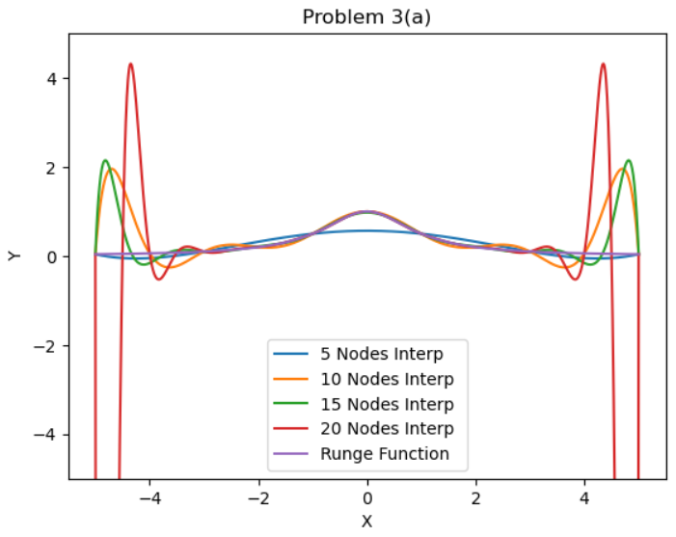

**Problem 3(b):**

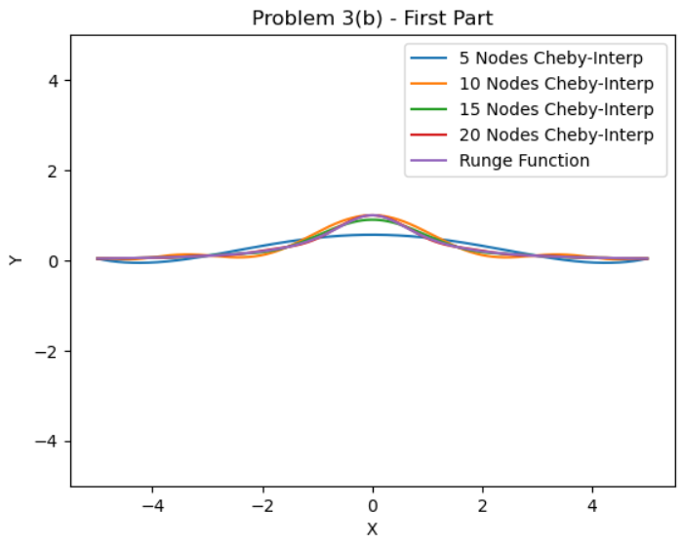

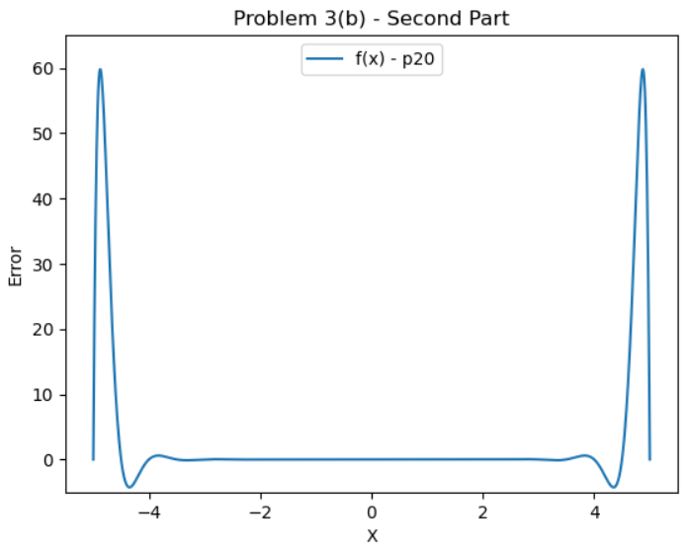

**Problem 4:**

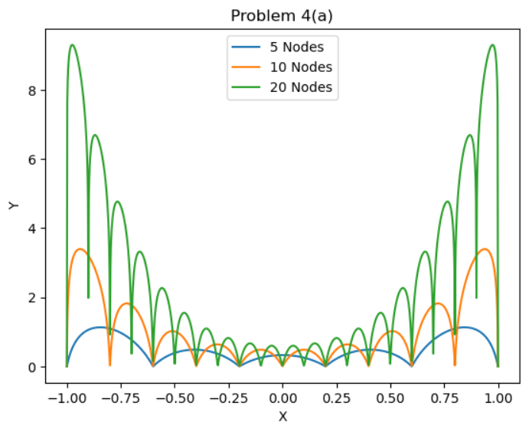

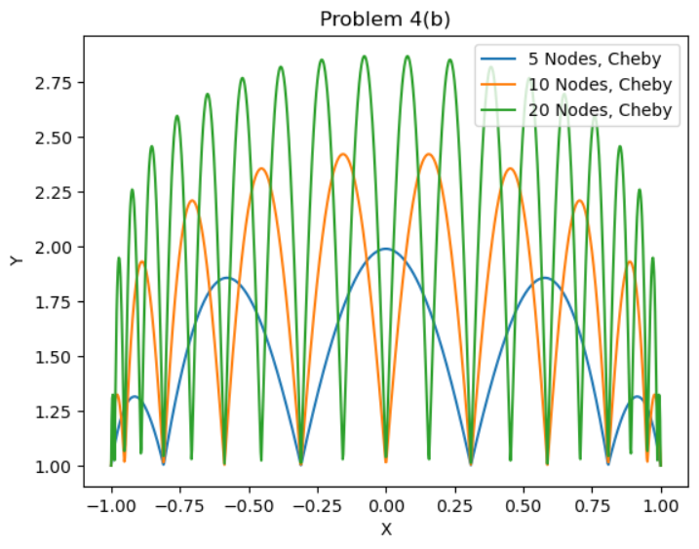

**Problem 4 (Comments):**

This is interesting. Noting that the plot for Problem 4(a) is the logarithm of the actual values (they are way larger before taking the logarithm), the values of the Lebesgue interpolating function really depend on the choice of interpolation nodes. In each case, you can see a bump corresponding to each node. If there are 5 nodes, then there are 5 bumps, and so on. Also in either case, the function seems to be generally larger when we add more nodes, which makes sense as we are summing more terms when we use more nodes.